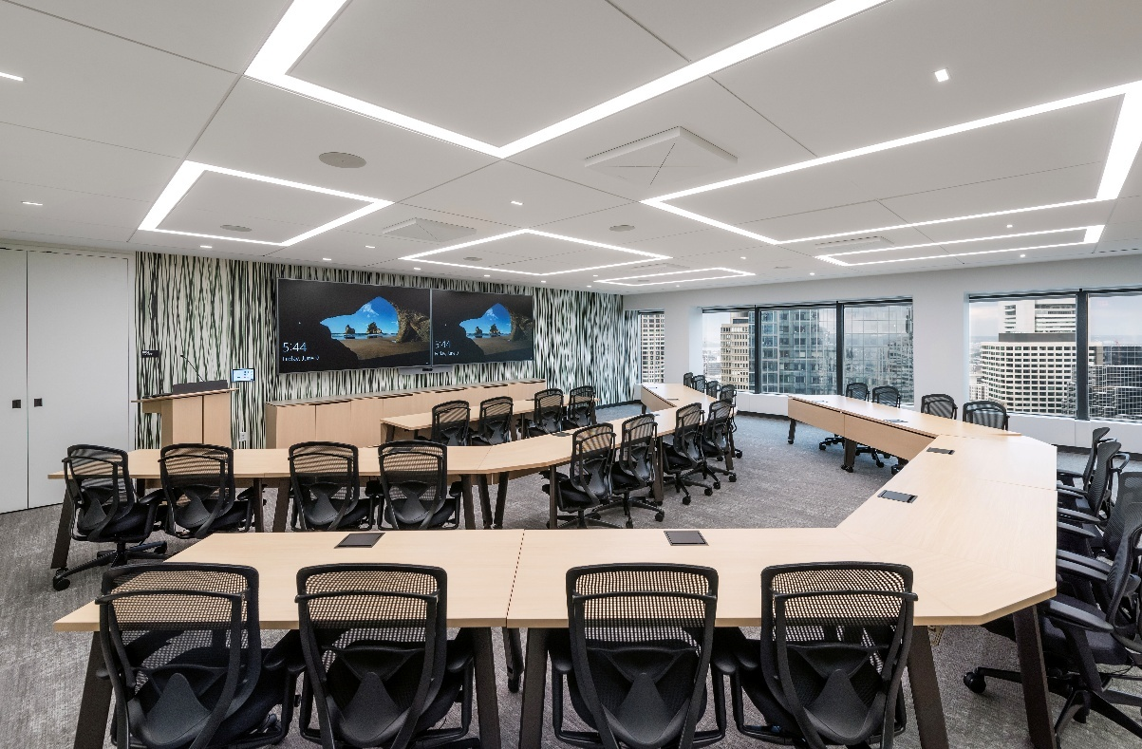

RoomReady Standardizes on Sennheiser’s TeamConnect Ceiling 2 Microphone When Delivering Predesigned AV Solutions to Customers

AV integrator has also equipped meeting rooms in its new headquarters with the TeamConnect Ceiling 2

Bloomington, IL — Dec. 10, 2024 — Sennheiser, the first choice for advanced audio technology that makes collaboration and learning easier, is proud to announce meeting room technology provider RoomReady has chosen the Sennheiser TeamConnect Ceiling 2 (TCC 2) as the standard ceiling microphone solution within its predesigned AV solutions. Named Room Menus, these predesigned and proven solutions include everything customers need for a certified video conferencing system. Following extensive testing, the TCC 2 was chosen for its ease of use and ability to deliver superior audio for various types of meeting spaces. RoomReady is a long time Sennheiser integrator, installing more than 1,000 TCC 2s since 2021.
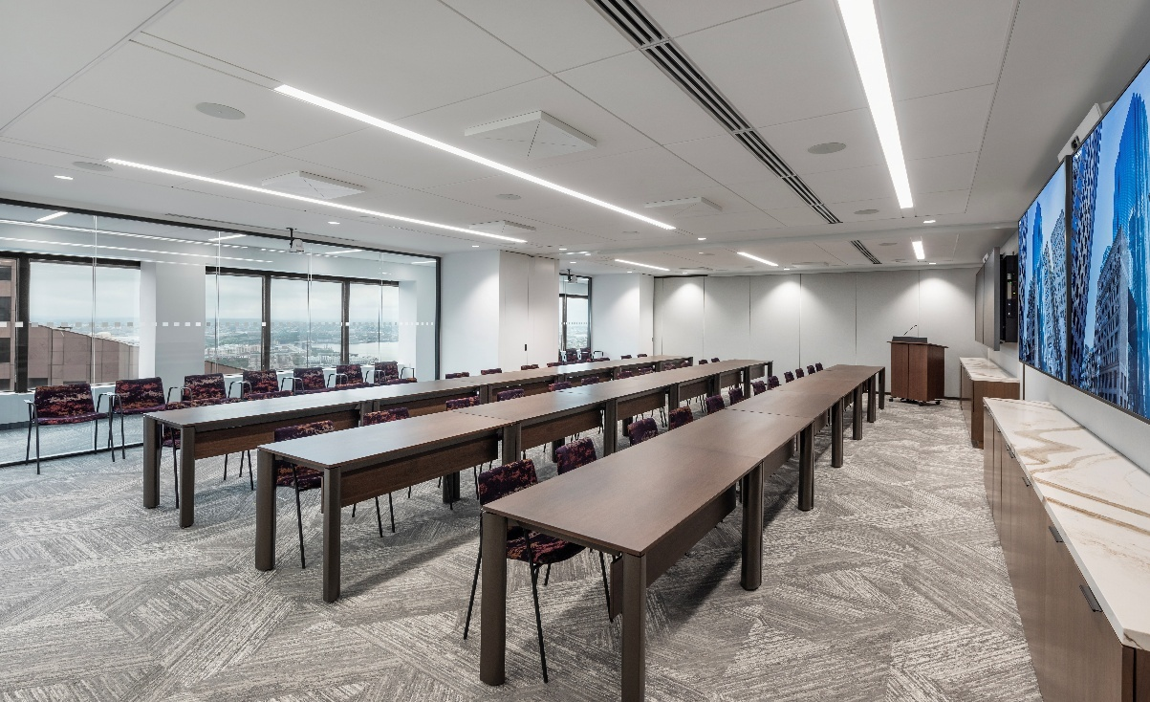
Training Room in a Room Ready Customer Headquarters Installation in Boston
As an additional proof point of RoomReady’s confidence in the TCC 2, the company recently installed the ceiling microphone in its new headquarters in Bloomington, Illinois. When it came time to design the meeting rooms within RoomReady’s new headquarters, the company wanted to showcase their streamlined approach to AV integration using TCC 2. These rooms embody RoomReady’s core values of simplicity, speed, and flexibility, while providing consistent, high-quality audio and a user-friendly experience.

A Simplified Approach to AV Integration
RoomReady is known as a pioneering AV integrator for simplifying the complexity of AV installations. The company’s mantra — simple is better, speed matters, and flexibility is key — defines every facet of their business, from solutions design to customer support. In 2024, the company opened its new Illinois headquarters in Bloomington, merging its main office in Norman with its warehouse and assembly facility. The resulting 40,000-square-foot headquarters houses shipping, receiving, assembly, and the Tech Lab, where the company field tests potential solutions in a staged meeting room environment.

Their unique methodology, known as The RoomReady Way, ensures that nearly all solutions are pre-assembled, tested, and certified before deployment, dramatically reducing installation times and minimizing downtime for their clients. The company also offers a 90-day warranty, a range of configuration options with clear pricing, and its proprietary RoomReady Set wall-mounted AV rack, making them a trusted partner in delivering simple, scalable, and organized AV solutions.

“With the RoomReady Way, our goal is to remove AV complexity by providing proven, standardized solutions through our Room Menus,” said Izzi Demara, RoomReady’s Marketing Manager. “We’re not just integrating technology; we’re delivering an intuitive, consistent experience that our clients can rely on, room after room.”

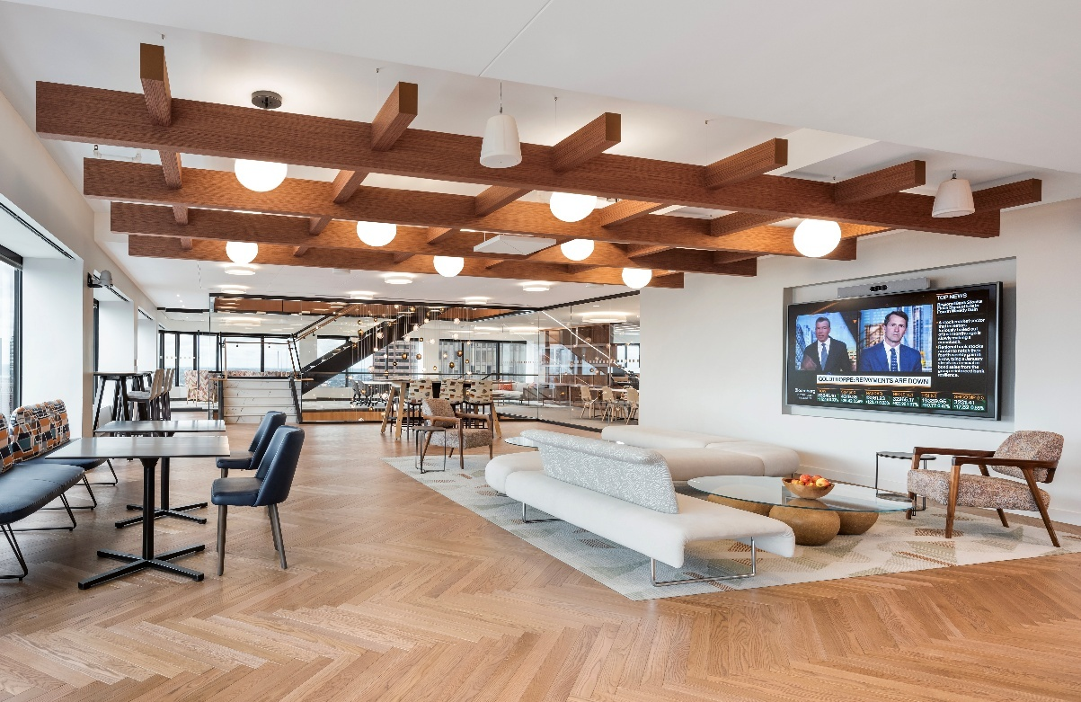
Open area the customer's Boston Headquarters

Meeting the Demands of Hybrid Work and UC Flexibility
As hybrid work became the new norm post-pandemic, RoomReady’s clients needed a unified communications (UC) solution that could meet the demands of the evolving workplace environment. Previous AV setups were no longer sufficient, as they relied heavily on hardware-based codecs that limited flexibility and required intensive maintenance. RoomReady needed a solution that could integrate seamlessly with various meeting platforms like Microsoft Teams, Zoom, and Cisco Webex. They also wanted a solution that could reduce the equipment footprint while maintaining high-quality audio. This technology needed to be able to support RoomReady’s commitment to consistent, simple, and effective meeting room functionality while being adaptable to different room configurations, offering flexible ceiling mounting options, and supporting both Dante and analog connections to meet specific client needs, especially for Cisco VoIP systems. The company chose Sennheiser’s TCC 2 following extensive testing in the Tech Lab, making it the ceiling microphone standard within its RoomReady room menus for larger meeting rooms.

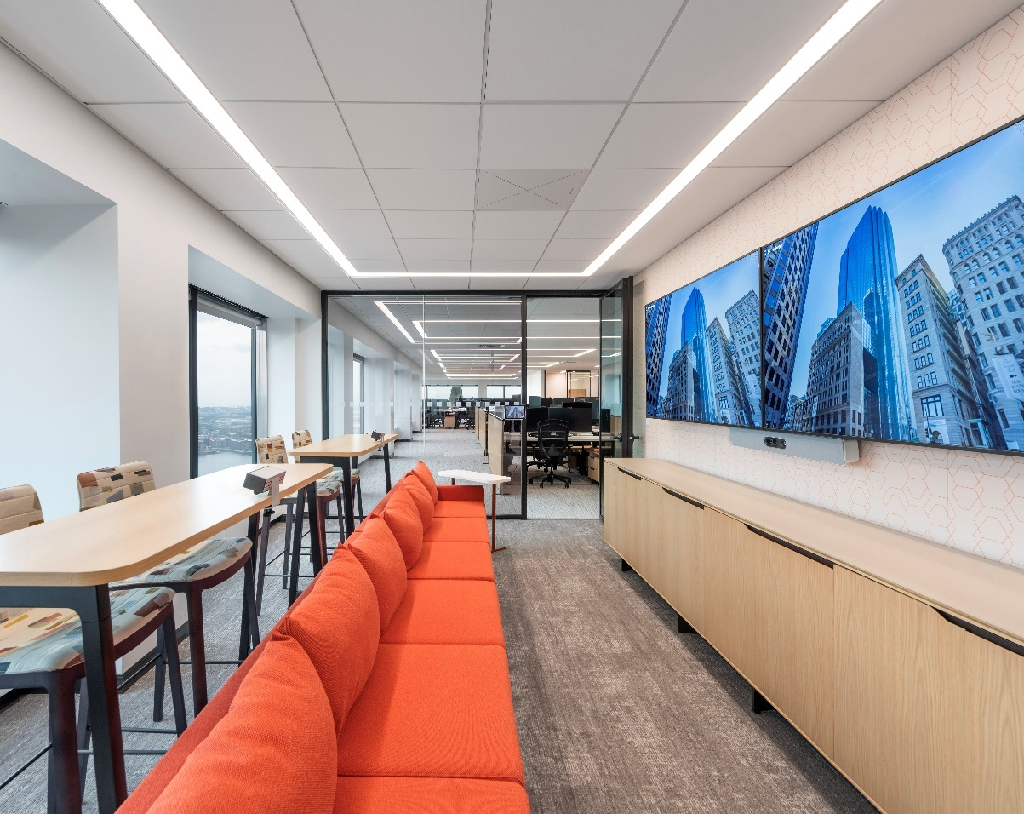
Conference Room A the customer's Boston Headquarters

A Solution That Simplifies Installation and Maintenance
Part of Sennheiser’s TeamConnect (TC) family, the TCC 2 stands out in this lineup, delivering trusted Sennheiser audio quality by using patented Dynamic Beamforming technology to capture perfect speech intelligibility from every corner of the room with exceptional clarity. This technology automatically tracks the position of speakers in the room and switches between speakers in real time, ensuring that their voices are clearly captured. This makes it an ideal choice for large sized meeting rooms, ensuring that no participant's voice goes unheard. From large meeting rooms to divisible training rooms, RoomReady is able to create a simple, high-quality meeting room environment with the TCC 2. The microphone's built-in 28 broadcast-quality microphone heads make the sound clear and natural, supporting both software-based video platforms and VoIP systems, thanks to its Dante and analog ports.

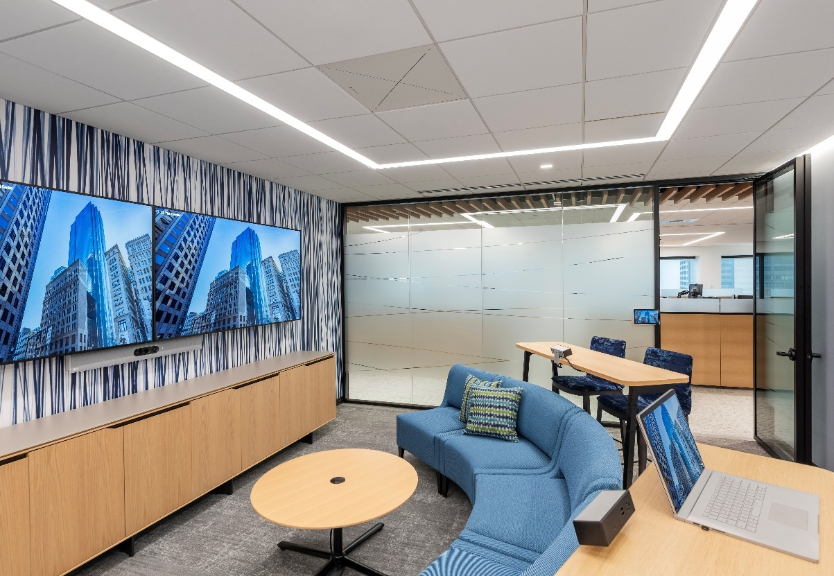
Conference Room B the customer's Boston Headquarters

“You can have 50 black boxes to make up an AV system or you can cut that down to five and minimize points of failure,” said Paul Stuckey, RoomReady’s director of sales engineering. “The TCC 2 means we don’t always need a DSP, reducing maintenance for end users. Simple is better — it’s plug-and-play, compatible with other manufacturers, and it works like the first time every time.”

The TCC 2’s flexible installation options made it an ideal fit for RoomReady’s varied room designs. The microphone can be recessed into the ceiling, ceiling-mounted, or suspended, allowing RoomReady to meet diverse architectural requirements. This adaptability was crucial to the RoomReady Way, enabling them to integrate the TCC 2 as their standard solution seamlessly across different room configurations without compromising on design or performance —helping to speed up quotes and installation.

To learn more about TCC 2, go to TeamConnect Ceiling 2 | Sennheiser.

###
About RoomReady
At RoomReady, our goal is to help you check meeting tech complexity at the door. Our innovations allow you to launch a meeting and connect colleagues across the room or around the world with a single touch. And our rapid-install teams ensure you get all of this in days, not weeks. The end result? Greater productivity, reduced costs, and a consistent user experience. If your rooms cause more frustration than collaboration, go with the team that’s committed to continually improving the meeting experience – one room at a time. RoomReady: We innovate. You collaborate. For more information, visit https://roomready.com/.

About the Sennheiser brand
We live and breathe audio. We are driven by the passion to create audio solutions that make a difference. Building the future of audio and bringing remarkable sound experiences to our customers – this is what the Sennheiser brand has represented for more than 75 years. While professional audio solutions such as microphones, meeting solutions, streaming technologies and monitoring systems are part of the business of Sennheiser electronic SE & Co. KG, the business with consumer devices such as headphones, soundbars and speech-enhanced hearables is operated by Sonova Holding AG under the license of Sennheiser.

www.sennheiser.com
www.sennheiser-hearing.com

